Abstract title
First Author¹, Second Author² and Last Author^{†2}
¹1001 boul. Décarie, Montréal, QC, CANADA H4A 3J1. ²1010 rue Ste-Catherine, Montréal, QC, CANADA H4A 3J1.
Instructions (Please delete this section of text.)
This template must be used to prepare your ICCR 2019 Short Paper, as part of your Abstract submission. Submissions with Short Papers that do not conform to this template may be rejected. This Short Paper should be submitted as a PDF.
- Please do not alter page layout, font type, font size, line spacing, margins, or the page header or footer.
- It is not necessary to include the Abstract (text submitted in the online system) in the short paper.
- The corresponding author should marked with † and their email address given at the end of the short paper.
- There is no word limit, but short papers must fit on two template pages and the total file size for upload must not be greater than 50 MB (when converted to PDF).
- Feel free to alter the section headings as appropriate for your short paper.
- Add as many figures and tables as necessary within the two page limit. All figures and tables must fit inside of the text column borders. Please maintain the formatting of caption text (boldface figure number, italicized text).
- Many thanks and we look forward to receiving your work.
Introduction
Lorem ipsum dolor sit amet, consectetur adipiscing elit. Praesent finibus felis scelerisque, egestas ex vitae, vulputate sapien. Nunc quis augue mollis, ullamcorper risus vitae, dapibus purus. Nam vehicula mi at tincidunt aliquam. Integer lacinia lobortis metus, auctor interdum urna eleifend vitae. Nullam eget accumsan sapien. Pellentesque sit amet gravida felis. Duis et ornare ipsum. Nunc vel leo sit amet arcu auctor tempor. Praesent aliquet urna blandit, pellentesque purus in, malesuada diam. Sed pretium posuere quam, id porttitor dolor. Donec venenatis lectus nec massa mollis, a porttitor eros luctus.
Materials & Methods
Praesent tempor iaculis nisl, sit amet dignissim libero viverra sit amet. Praesent ac rhoncus est. Pellentesque euismod libero scelerisque maximus efficitur. Maecenas sollicitudin ac dui sed tincidunt. Donec convallis dui tincidunt dolor tincidunt, vel porta nibh varius. Sed pretium posuere quam, id porttitor dolor. Donec venenatis lectus nec massa mollis, a porttitor eros luctus. Sed pretium posuere quam, id porttitor dolor. Donec venenatis lectus nec massa mollis, a porttitor eros luctus. Aenean dapibus gravida augue non feugiat. Pellentesque ac sapien odio. Sed pretium posuere quam, id porttitor dolor. Donec venenatis lectus nec massa mollis, a porttitor eros luctus. Nunc vel leo sit amet arcu auctor tempor. Praesent aliquet urna blandit, pellentesque purus in, malesuada diam.
Results
Praesent tempor iaculis nisl, sit amet dignissim libero viverra sit amet. Praesent ac rhoncus est. Pellentesque euismod libero scelerisque maximus efficitur. Maecenas sollicitudin ac dui sed tincidunt. Donec convallis dui tincidunt dolor tincidunt, vel porta nibh varius. Sed pretium posuere quam, id porttitor dolor. Donec venenatis lectus nec massa mollis, a porttitor eros luctus.
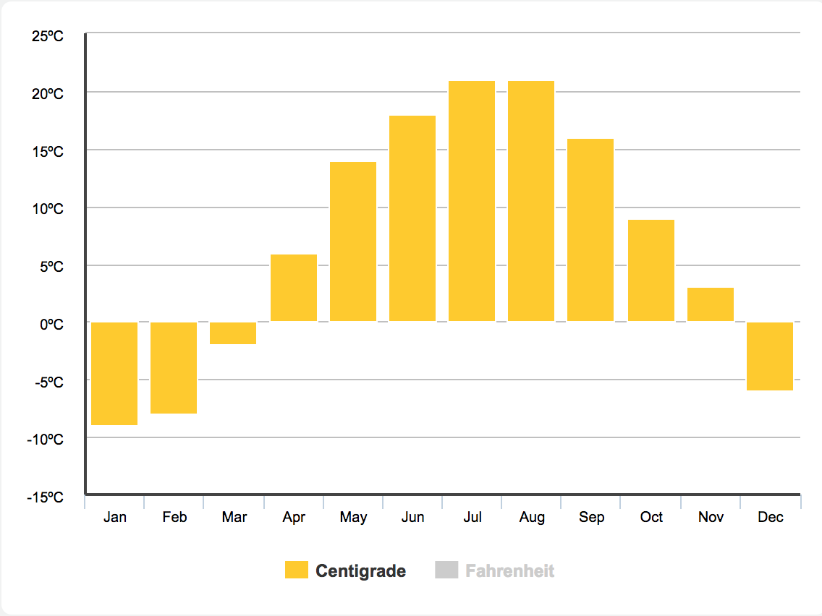
Figure 1: Average temperature in Montreal, Quebec [1].
Praesent tempor iaculis nisl, sit amet dignissim libero viverra sit amet. Praesent ac rhoncus est. Pellentesque euismod libero scelerisque maximus efficitur. Maecenas sollicitudin ac dui sed tincidunt. Donec convallis dui tincidunt dolor tincidunt, vel porta nibh varius. Sed pretium posuere quam, id porttitor dolor. Donec venenatis lectus nec massa mollis, a porttitor eros luctus.
Discussion & Conclusions
Donec scelerisque leo non massa aliquam eleifend. Duis luctus, neque vitae convallis tempus, nisl dui rhoncus velit, porta rutrum diam odio a leo. Nam congue justo maximus libero blandit, vitae fringilla eros maximus. Mauris sapien orci, pretium eu erat malesuada, mattis vehicula nunc. Fusce eget nunc nec orci sodales dictum. Nam ultricies, elit quis volutpat sollicitudin, augue lacus dignissim augue, eu ornare erat ante et nibh. In luctus dui scelerisque felis malesuada, ac tincidunt mi tristique.
References
[1] https://www.holiday-weather.com/montreal/averages/
Acknowledgements
Morbi a accumsan ipsum, quis posuere mi. Maecenas varius turpis in ipsum tempus sollicitudin. Praesent aliquam quam sit amet interdum varius. Aenean dapibus gravida augue non feugiat. Pellentesque ac sapien odio.
†Corresponding Author: Last.Author@somewhere.org

